

OSH Training Report

Title | Introduction to OSH and how it relates to our everyday life
Date | 7th June 2011 (Tuesday)
Time | 11.00 a.m. to 12.30 p.m.
Venue | F10, Training Room
Presenter | Benedict Tong, HR, Safety & Training Asst. Manager / SHO
Number of participants | 28, see attachment, training material same as previous

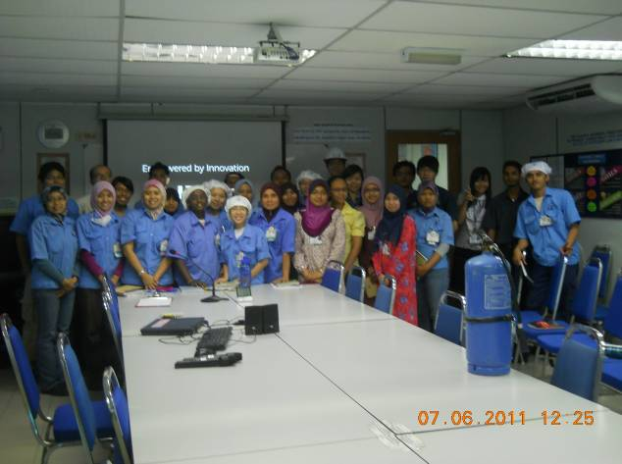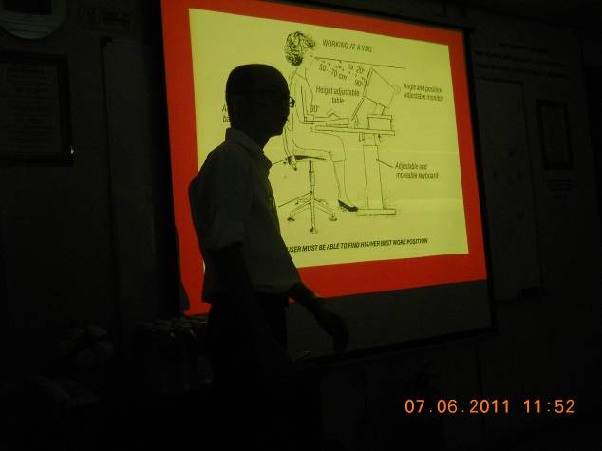

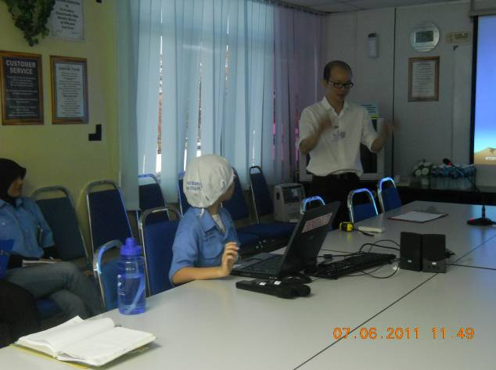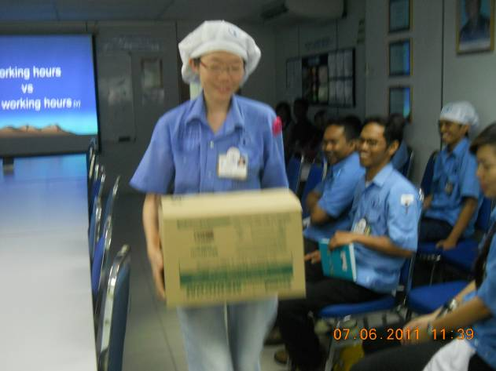

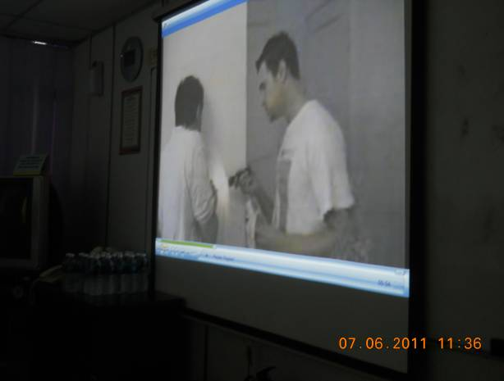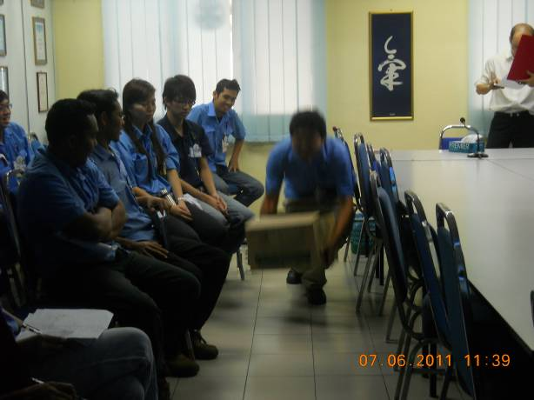
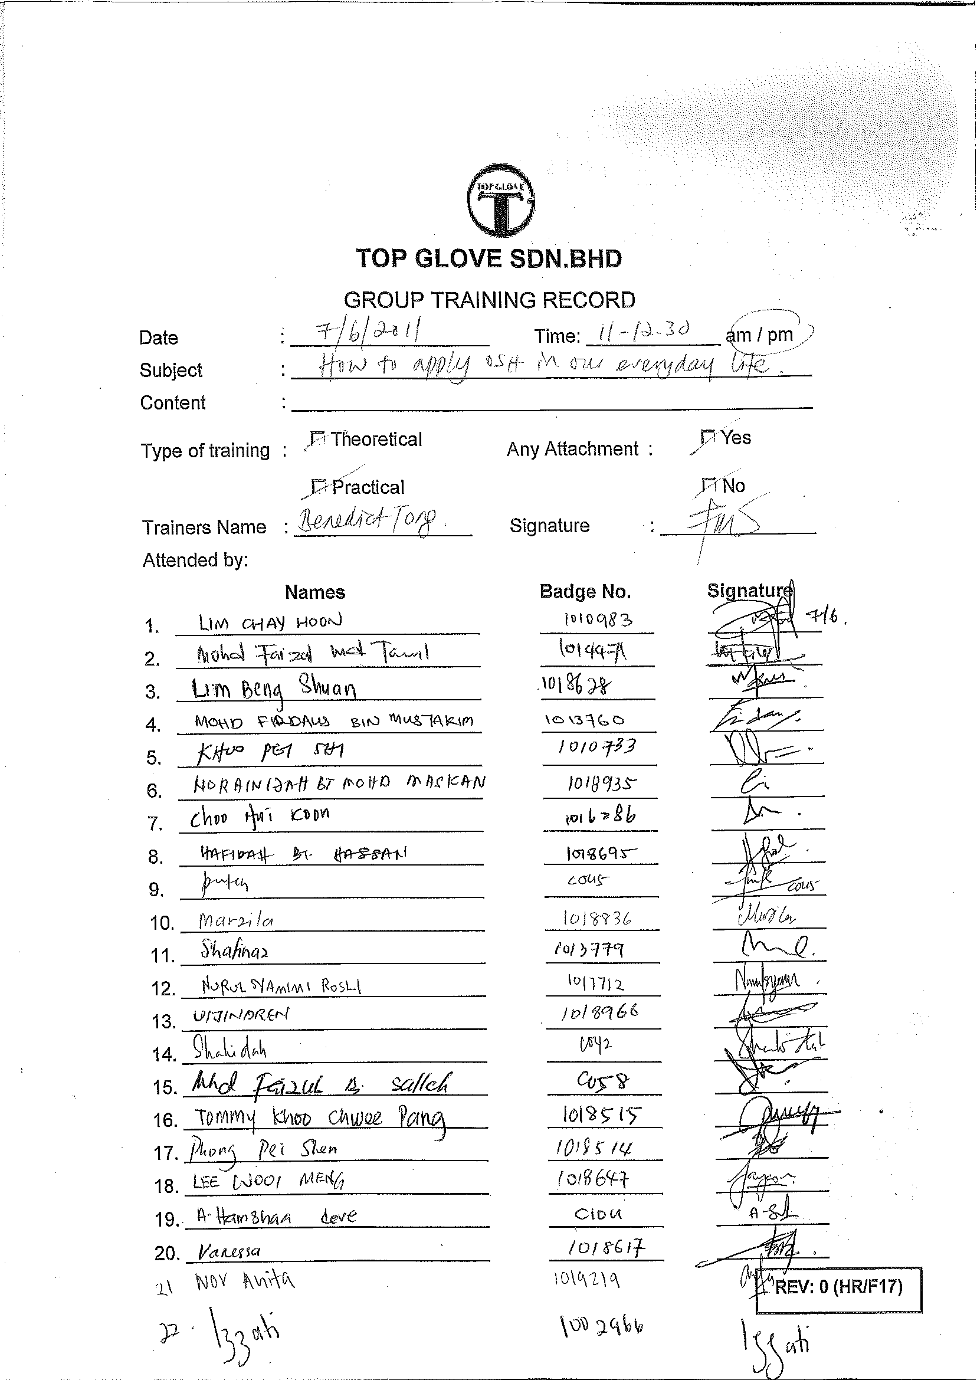

At the Q & A session, the questions that had been asked by the previous participants, been told:

